Technical Report on PowerBI/SQL Pizza Sales Analysis Dashboard
For The Year 2024
PIZZA SALES SQL QUERIES
- KPI’s
- Total Revenue:
SELECT sum(total_price) AS Total_Revenue From pizza_data
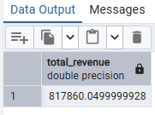
- Average Order Value:
SELECT sum(total_price) / COUNT (DISTINCT order_id) AS Avg_order_value FROM pizza_data
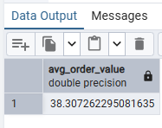
- Total Pizza Sold:
SELECT sum(quantity) AS Total_Pizza_Sold FROM pizza_data
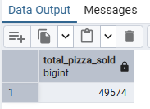
- Total Orders
SELECT COUNT(DISTINCT order_id) AS Total_Orders FROM pizza_data
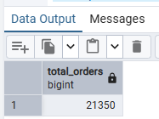
- Average Pizza per Order
SELECT CAST(CAST(sum(quantity) AS DECIMAL(10,2))/ CAST(COUNT (DISTINCT order_id) AS DECIMAL (10,2)) AS DECIMAL(10,2)) AS Avg_pizza_per_value FROM pizza_data
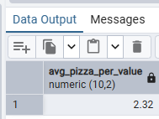

Charts Requirement
- Daily Trend for Total Orders

- Hourly Trend for Orders

- % of Sales by Pizza Category

SELECT pizza_category, Sum(total_price) * 100 / (SELECT sum(total_price) FROM pizza_data) as PCT FROM pizza_data

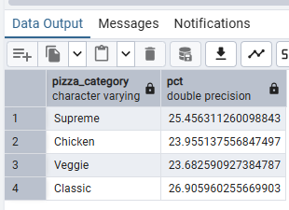
- Group by pizza_category
SELECT pizza_size, CAST(Sum(total_price) * 100 / (SELECT sum(total_price) FROM pizza_data) AS DECIMAL (10,2)) as PCT FROM pizza_data
Group by pizza_size
Order by pct DESC
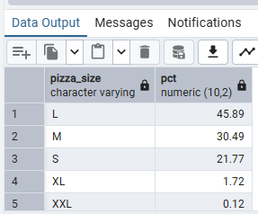
- Top 5 Pizza By Revenue
SELECT pizza_name, SUM(total_price) AS Total_Revenue FROM pizza_data
Group by pizza_name
Order by Total_Revenue DESC
Limit 5
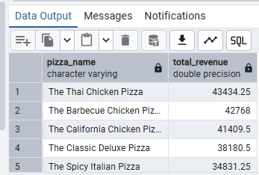

- Bottom 5 Pizza by Revenue
SELECT pizza_name, SUM(total_price) AS Total_Revenue FROM pizza_data
Group by pizza_name
Order by Total_Revenue ASC
Limit 5
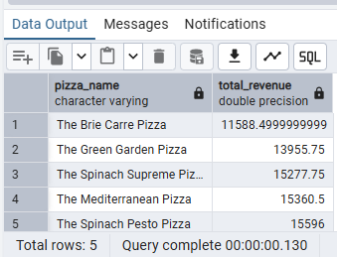

- Top 5 pizza by Quantity
SELECT pizza_name, SUM(quantity) AS Total_quantity FROM pizza_data
Group by pizza_name
Order by Total_quantity DESC
Limit 5
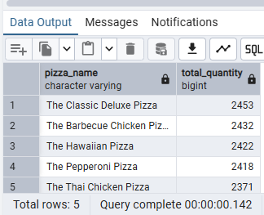
- Bottom 5 pizza by Quantity
SELECT pizza_name, SUM(quantity) AS Total_quantity FROM pizza_data
Group by pizza_name
Order by Total_quantity ASC
Limit 5
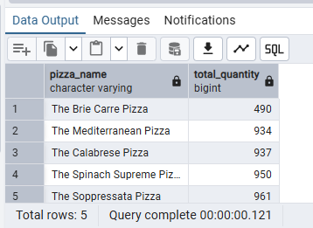

- Top 5 pizza by Order
SELECT pizza_name, COUNT(DISTINCT order_id) AS Total_Orders FROM pizza_data
Group by pizza_name
Order by Total_Orders DESC
Limit 5
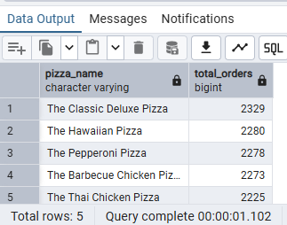

- SELECT pizza_name, COUNT(DISTINCT order_id) AS Total_Orders FROM pizza_data
Group by pizza_name
Order by Total_Orders ASC
Limit 5
